**Assignment 07 Template**

**Instructions for completing template:**Replace **[bracketed red text]** with the requested information or screen capture.  
Replace **bracketed red text with black text** and then remove the brackets.  
Do not include full screen shot images, or full screen shots that are reduced in size. Use a snippet tool to capture parts of the screen and insert those images into the template.  
Do not remove tags from this template. Please answer all questions.  
**Please do not alter the formatting or delete parts of this template.**  
Assignment questions are not as detailed as activity questions.   
The assignment is where you demonstrate understanding of the material.

**Part A - Student Information**

1. Student Name: [SYED AFTAABUDDIN] [A01]
2. Student Email: [syedaftab299@gmail.com] [A02]
3. Student Phone number: [7737960029] [A03] *OPTIONAL

Go back to the instructions and begin work on part B.

**Part B - Create 1 Drupal 8/9 CMS Website – not Codeanyhwere**

1. Create a Drupal 9 site on your Shared Web Host + cPanel, Localhost.  
   Which did you select to do this assignment and create your Drupal 9 site on?   
   [B01.1]  
   [Namecheap]

-OR-

Create a Drupal 8/9 site on Pantheon. If Pantheon supports building Drupal 9, then build a Drupal 9 site. If not, please build a Drupal 8 site.  
Which Drupal version did you build on Pantheon?   
[B01.2]  
[Pantheon Drupal version]

1. Based on the Platform selected in #1, complete the appropriate site info block:  
   Web Host Information: [B02]
   1. Shared Web Host Drupal 9 CMS Site Information:
      1. Website Admin Username: [saftaabu]
      2. Website Admin Password: [T#v29T#Z^dA9@]
      3. Database Name: [drup458]
      4. Table Prefix: [drs2_]
      5. Drupal CMS Website URL: [http://syedaftab.tech/assign07/]
   2. Pantheon – Drupal 8/9 CMS Site Information:
      1. **Pantheon Drupal version: [**Drupal version here**]**
      2. **Assignment Website Site Name:** **[**Site Name here**]**
      3. **WEBSITE Admin Username:** **[**Admin Username here**]**
      4. **WEBSITE Admin Password:** **[**Admin Password here**]**
      5. **Pantheon Frontend Website URL:** **[**Frontend website URL here**]**
   3. Localhost Drupal 9 CMS Site Information:
      1. Website Admin Username: [Enter Website Admin Username here]
      2. Website Admin Password: [Enter Website Admin Password here]
      3. Database Name: [Enter Database Name here]
      4. Table Prefix: [Leave Empty]  
         ACQUIA Dev Desktop DB’s typically do not build with a prefix
      5. Drupal CMS Website URL: [Enter Local host Website URL here]

Go back to the instructions and begin work on Part C. **Part C - Share Web Host – Harden the site**

1. SCREEN CAPTURE of the backend Admin toolbar > Accounts setting > REGISTRATION AND CANCELATION section  
   **[C01]**

**[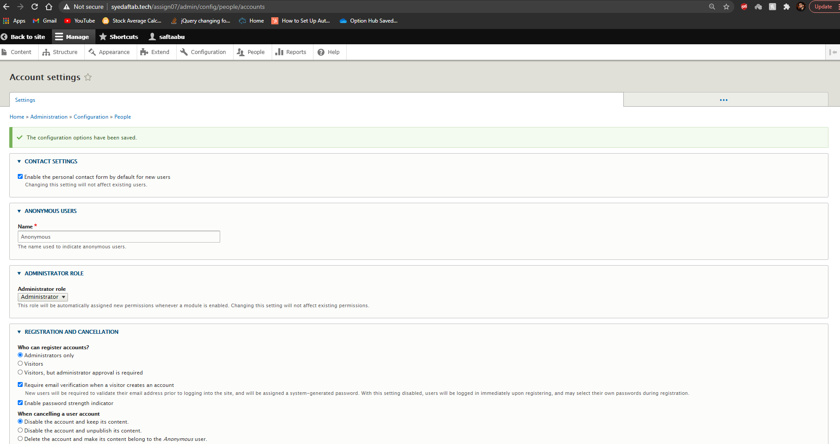]**

1. SCREEN CAPTURE of the backend Admin toolbar > People page  
   *To check that a strong username was used to create the site – in other words, not “admin”*  
   **[C02]**  
   **[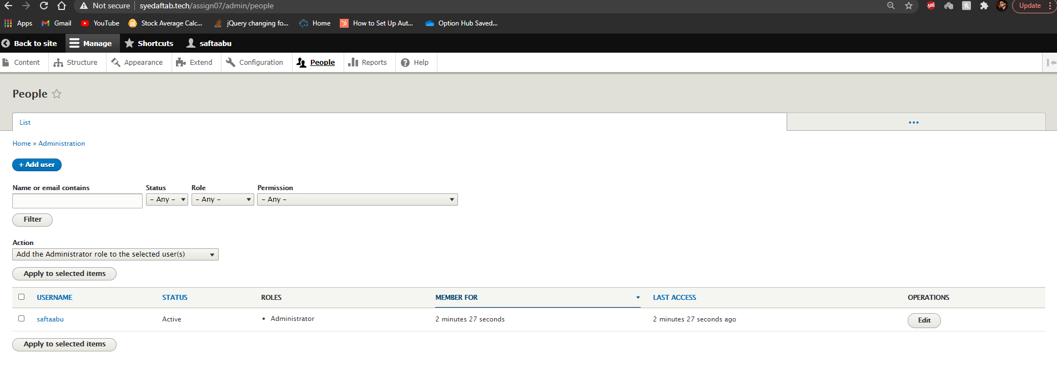]**

Go back to the instructions and begin work on Part D**.**

Part D - Extend the Drupal 9 CMS Site with an Admin Theme

1. SCREEN CAPTURE of the backend Admin toolbar > Appearance page  
   Screen captures showing all themes – Installed, Uninstalled, and selected Admin theme  
   **[D01]**

**[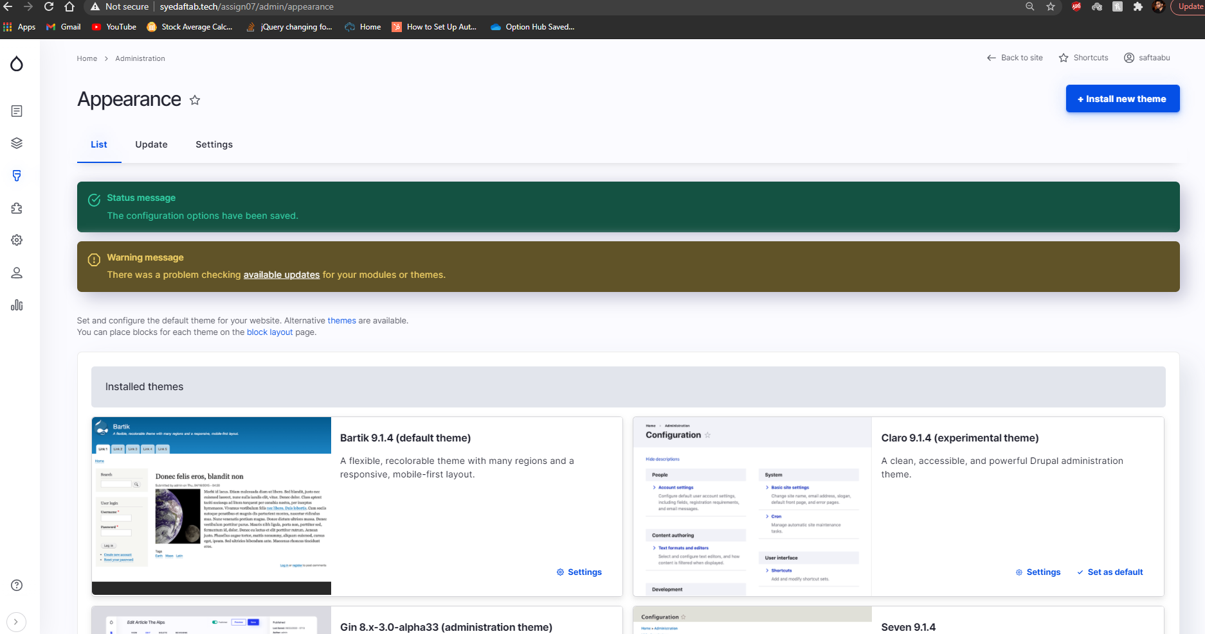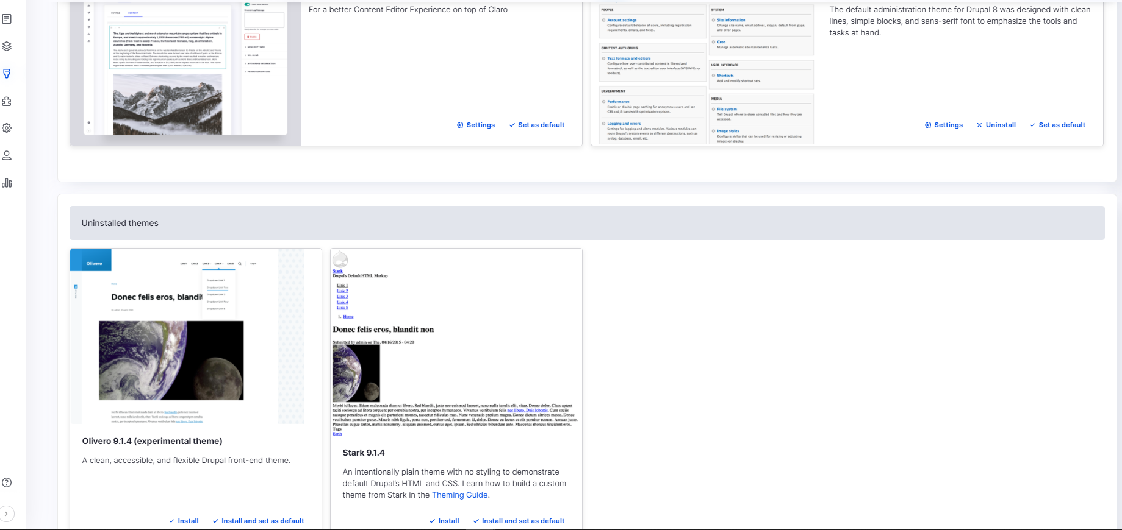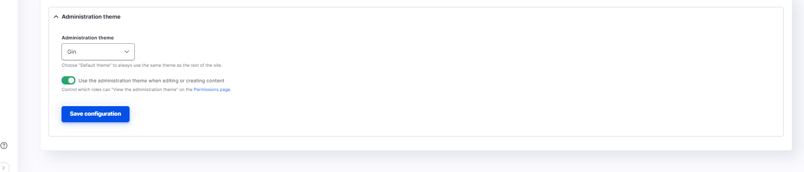]**

1. SCREEN CAPTURE of the backend Admin toolbar > Appearance page  
   Screen captures showing the selected Admin theme  
   **[D02]**

**[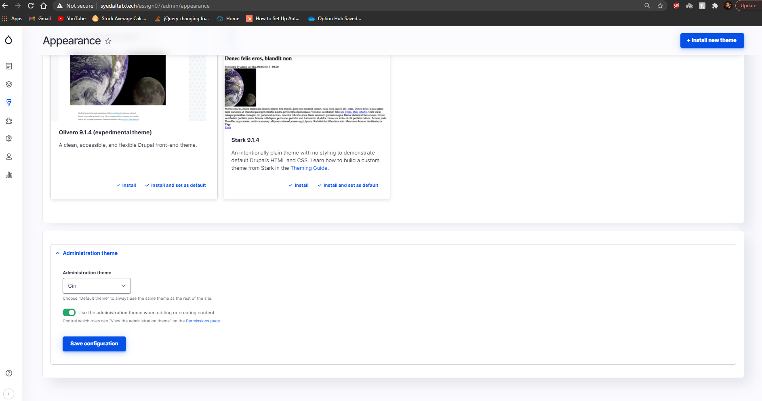]**

Part E - Extend the Drupal 9 CMS Site with a Frontend Client Facing Theme

1. SCREEN CAPTURE of the backend Admin toolbar > Appearance page  
   Screen captures showing Vani as the top listed and Default theme

**[E01]**

**[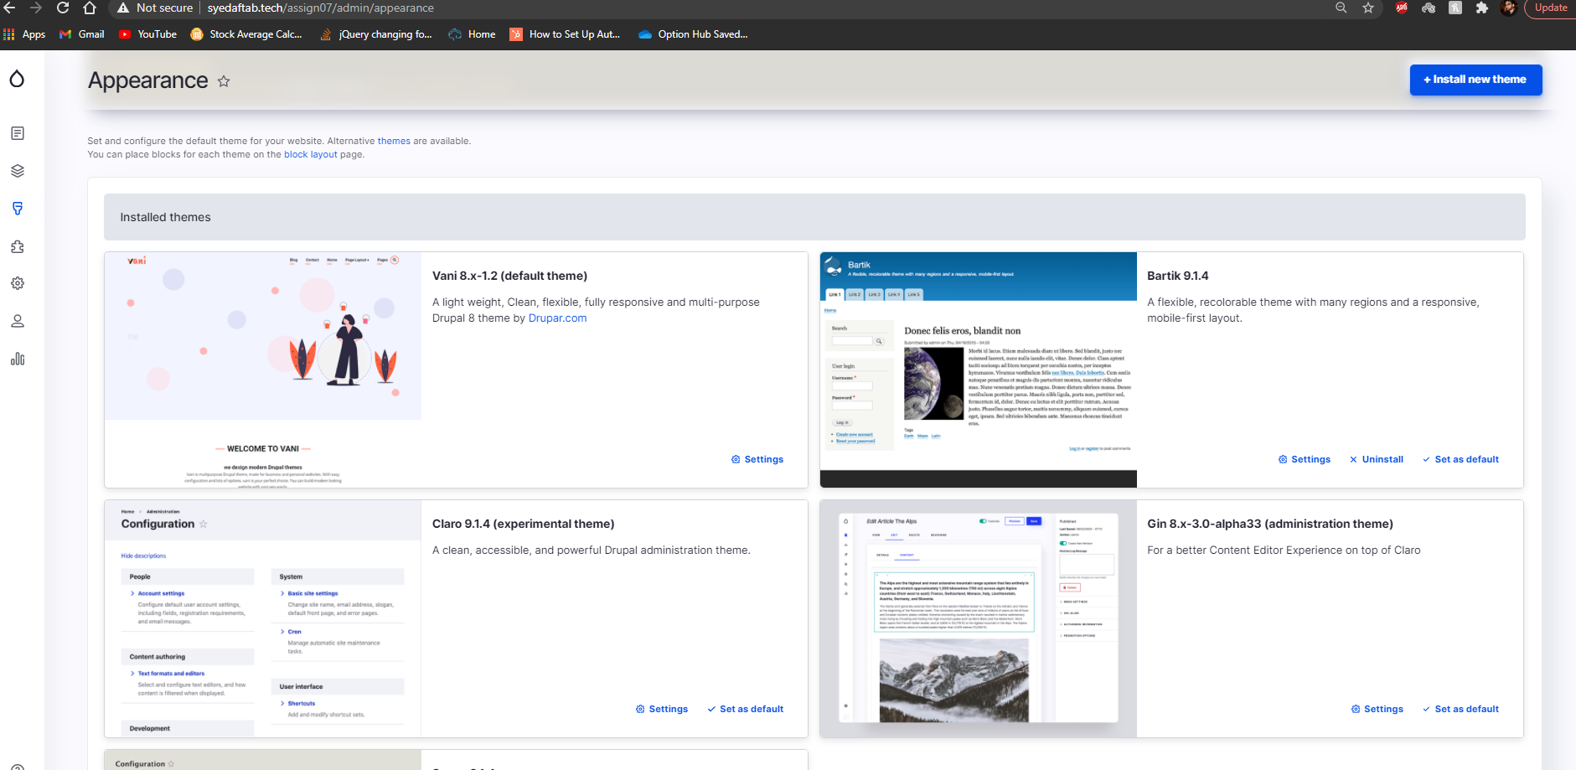]**

1. SCREEN CAPTURE of the Vani theme settings main page  
   **[E02]**

**[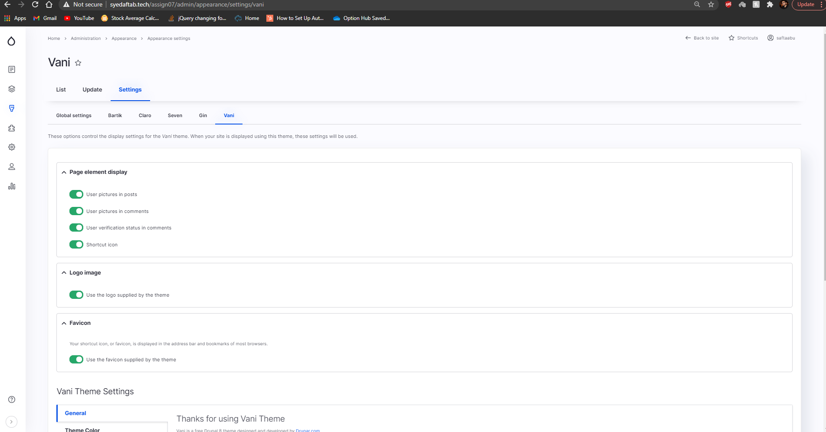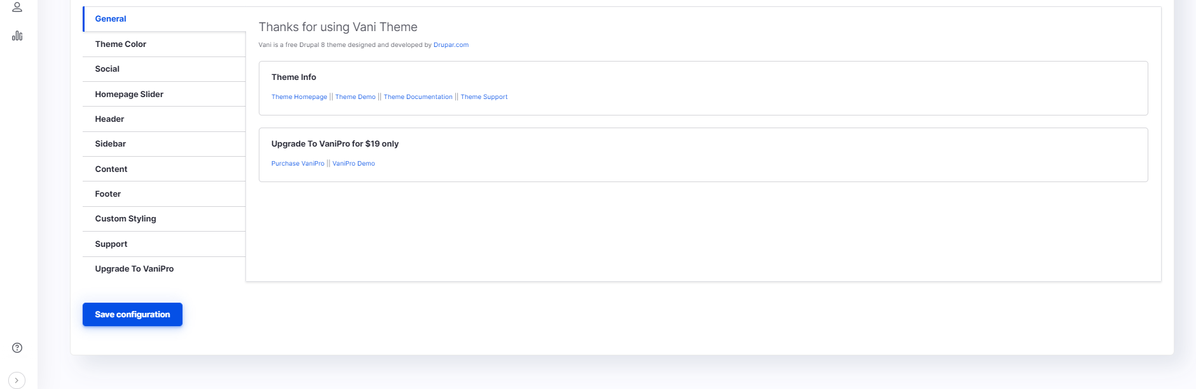]**

1. SCREEN CAPTURE of the Vani theme settings – Homepage Slider settings (all parts)  
   **[E03]**

**[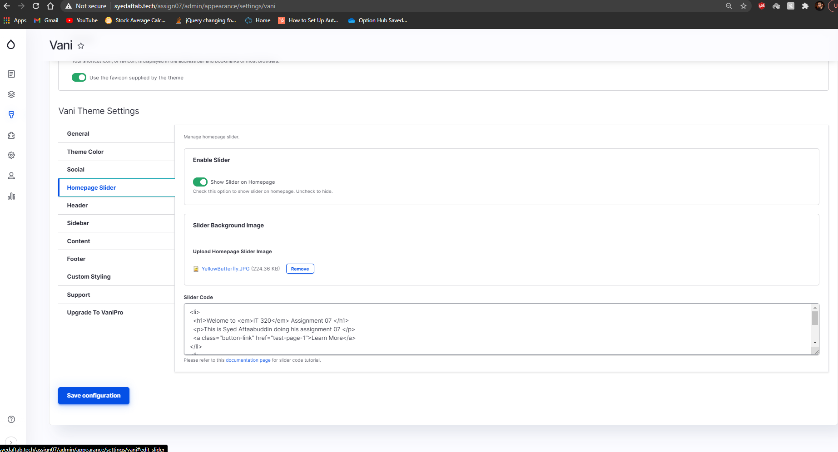]**

Part F - Extend the Drupal 9 CMS Site with Page Content

1. SCREEN CAPTURE of the backend Admin toolbar > Content – filter Content type by   
   Basic page  
   **[E01]**

**[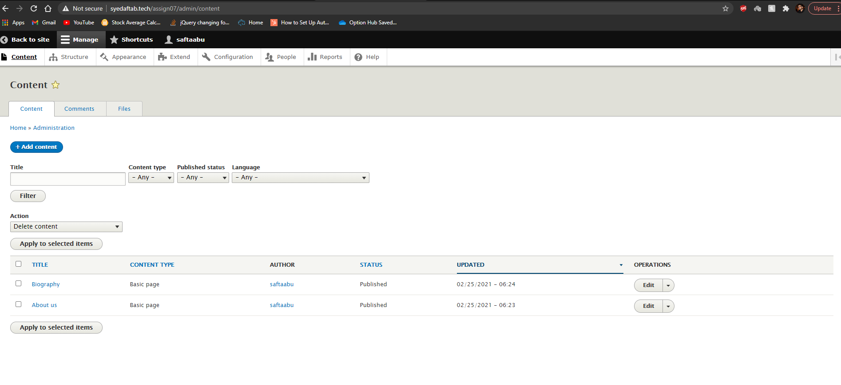]**

1. While logged in as the site Admin, Edit one of the Basic page nodes. Take screen captures of the template, capturing all the settings and paste those captures here. It may take more than one screen capture.   
   **[E02]**  
   **[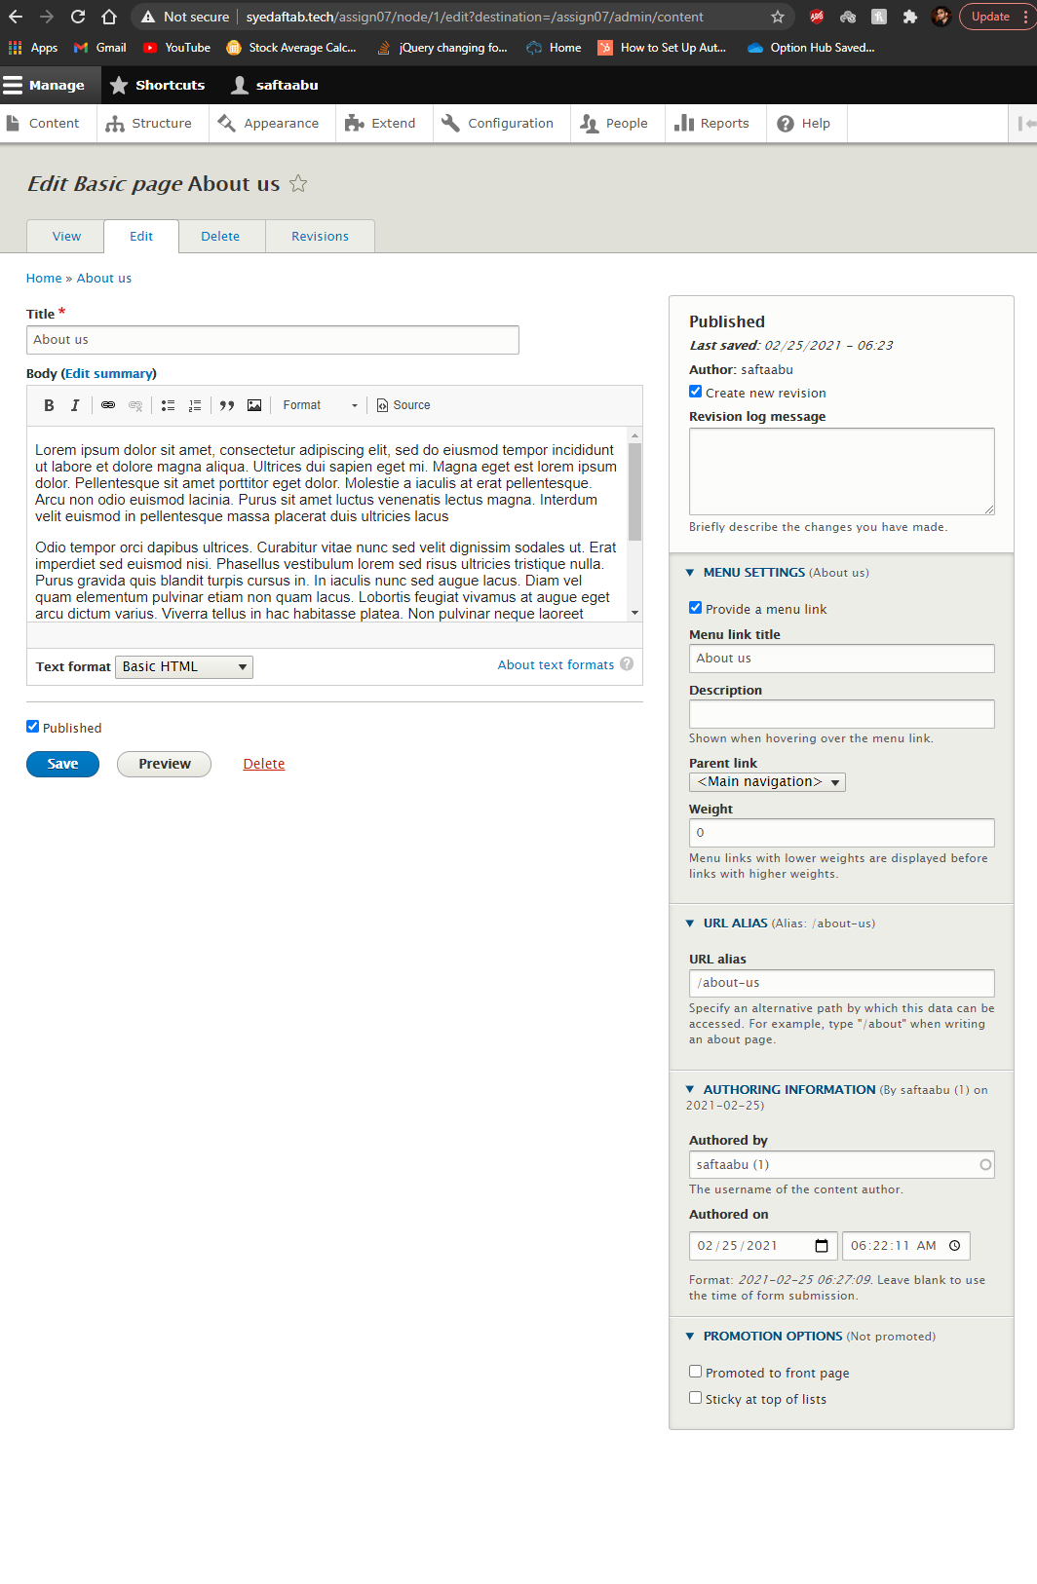]**
2. SCREEN CAPTURE of the front-end Drupal website with the web browser address bar visible after selecting a Basic Page menu item from the main menu  
   **[E03]**  
   **[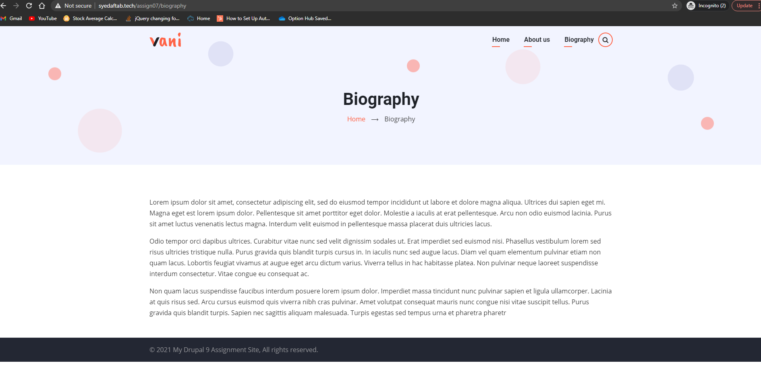]**

Part G - Extend the Drupal 9 CMS Site with Article Content

1. SCREEN CAPTURE of the backend Admin toolbar > Content – filter Content type by Article   
   **[G01]**

**[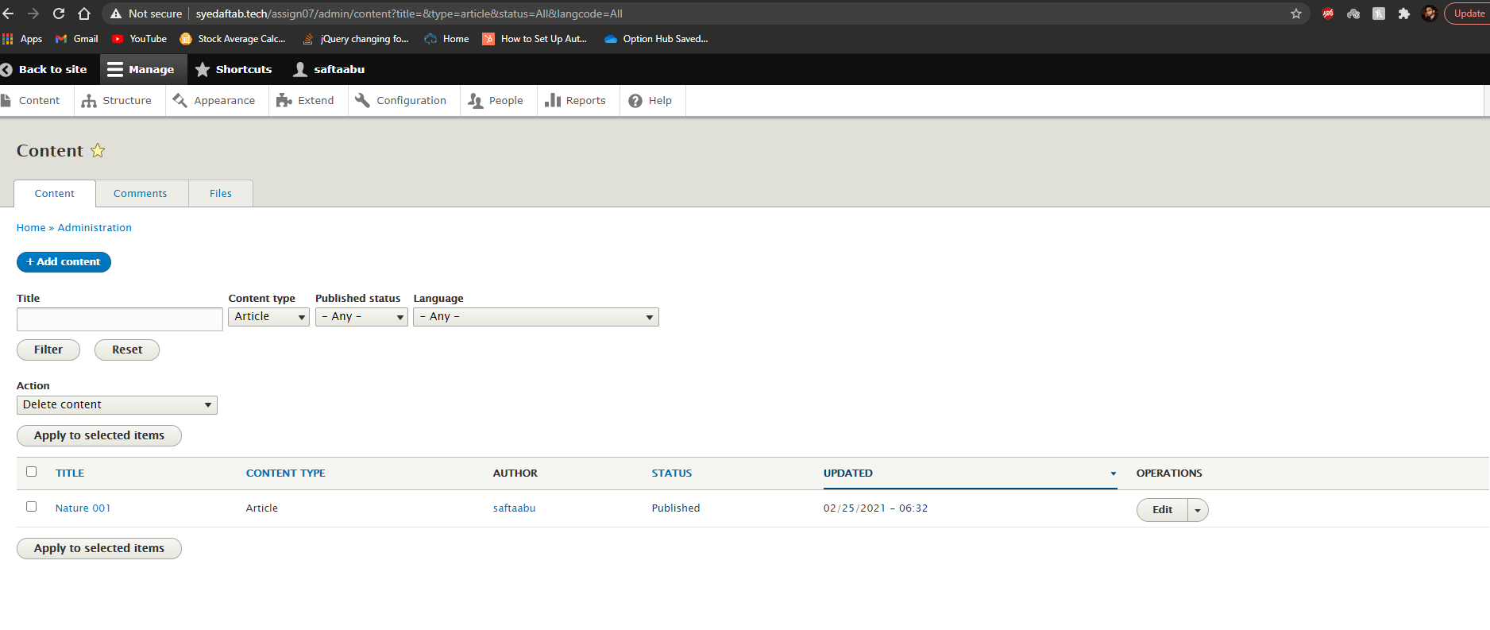]**

1. While logged in as the site Admin, Edit one of the Article nodes. Take screen captures of the template, capturing all the settings and paste those captures here. It may take more than one screen capture.   
   **[G02]**  
   **[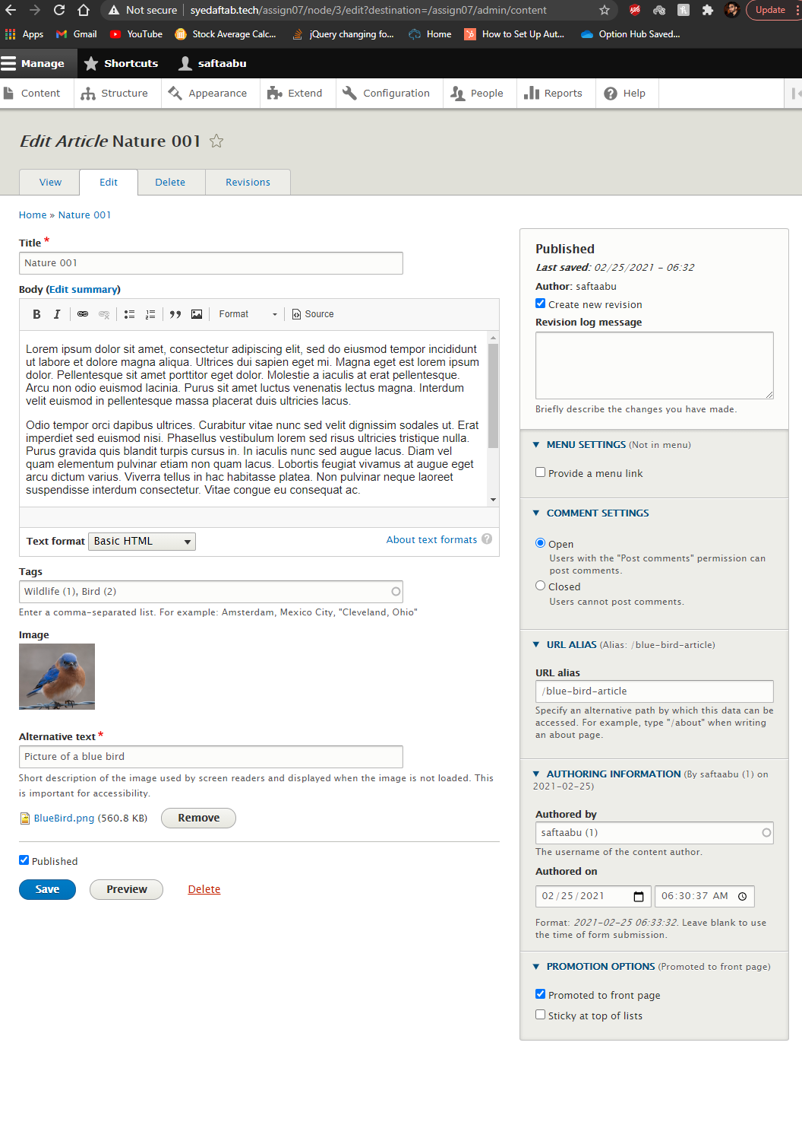]**
2. SCREEN CAPTURE of the backend Admin toolbar > Configuration > URL alias  **[G03]  
    [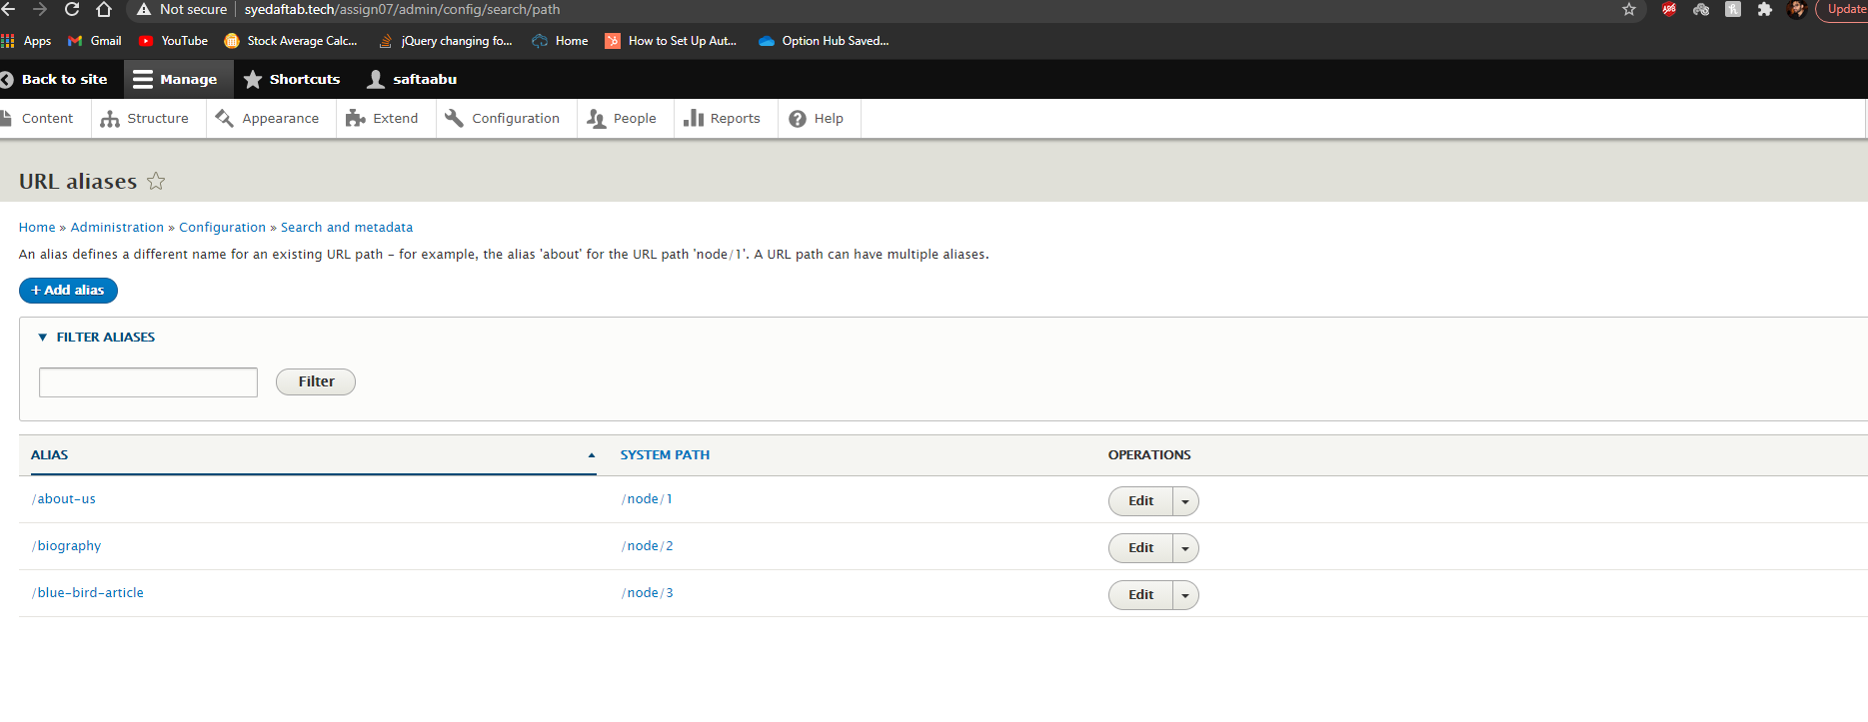]**
3. SCREEN CAPTURE of the front-end Drupal website with the web browser address bar visible while on the home page showing the Articles  
   **[G04]**  
   **[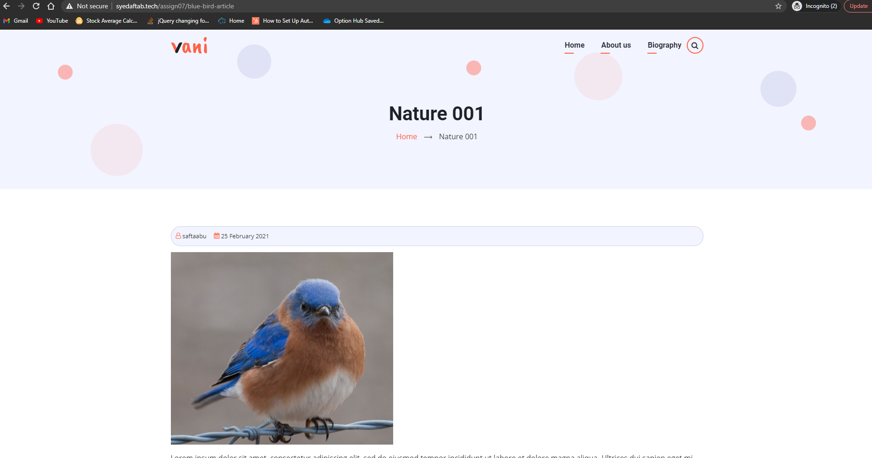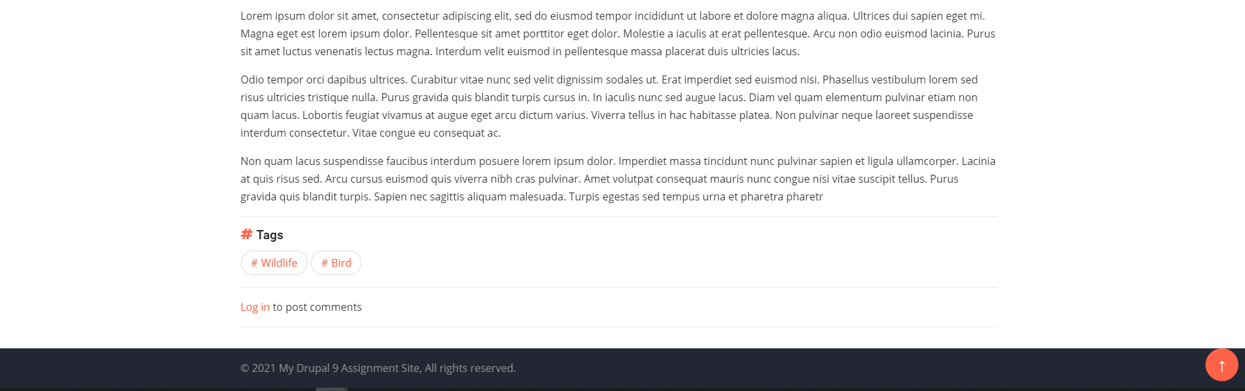]**

Go back to the instructions and begin work on Part H.

**Part H - Codeanywhere account Drupal 9 CMS site Info**

Drupal 9 Version Info:

1. Which website URL did you use to determine the most recent version of Drupal 9? **[H01]** **[**https://www.drupal.org/project/drupal/releases**]**
2. Which version of Drupal 9 did you when you build the Drupal 9 site on your Codeanywhere account? **[H02]** **[**Drupal 9.1.4**]**

Codeanywhere account info:

1. **Codeanywhere account Username (email): [H03]** **[**saftaabu**]**
2. **Codeanywhere account Password:** **[H04] [**50297006@Sps**]**

Codeanywhere Drupal 9 Website Info:

1. **Drupal 9 CMS Website URL:** **[H05] [**http://sa-assign07-ca-syedaftab299999760.codeanyapp.com/**]**
2. **Website Admin Username:** **[[H06] [**saftaabu**]**
3. **Website Admin Password:** **[H07] [**50297006@Sps**]**

Go back to the instructions and begin work on Part I.

**Part I – Codeanywhere – Harden the Drupal site**

1. SCREEN CAPTURE of the backend Admin toolbar > Accounts setting > REGISTRATION AND CANCELATION section  
   **[I01]**

**[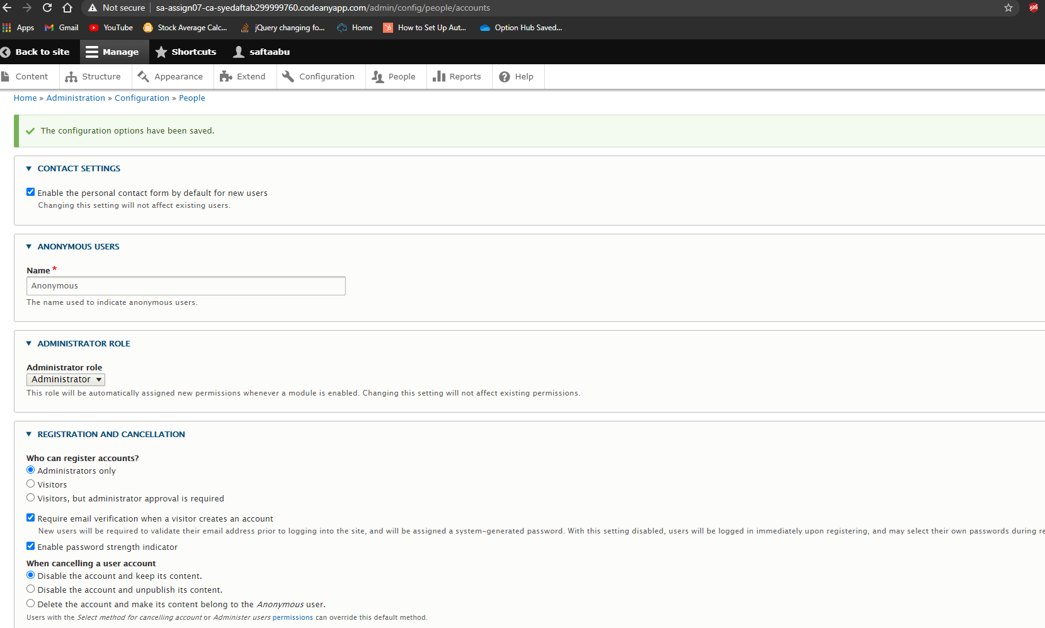]**

1. SCREEN CAPTURE of the backend Admin toolbar > Appearance page  
   Screen captures showing “Olivero”.as the top listed and Default theme

**[I02]**

**[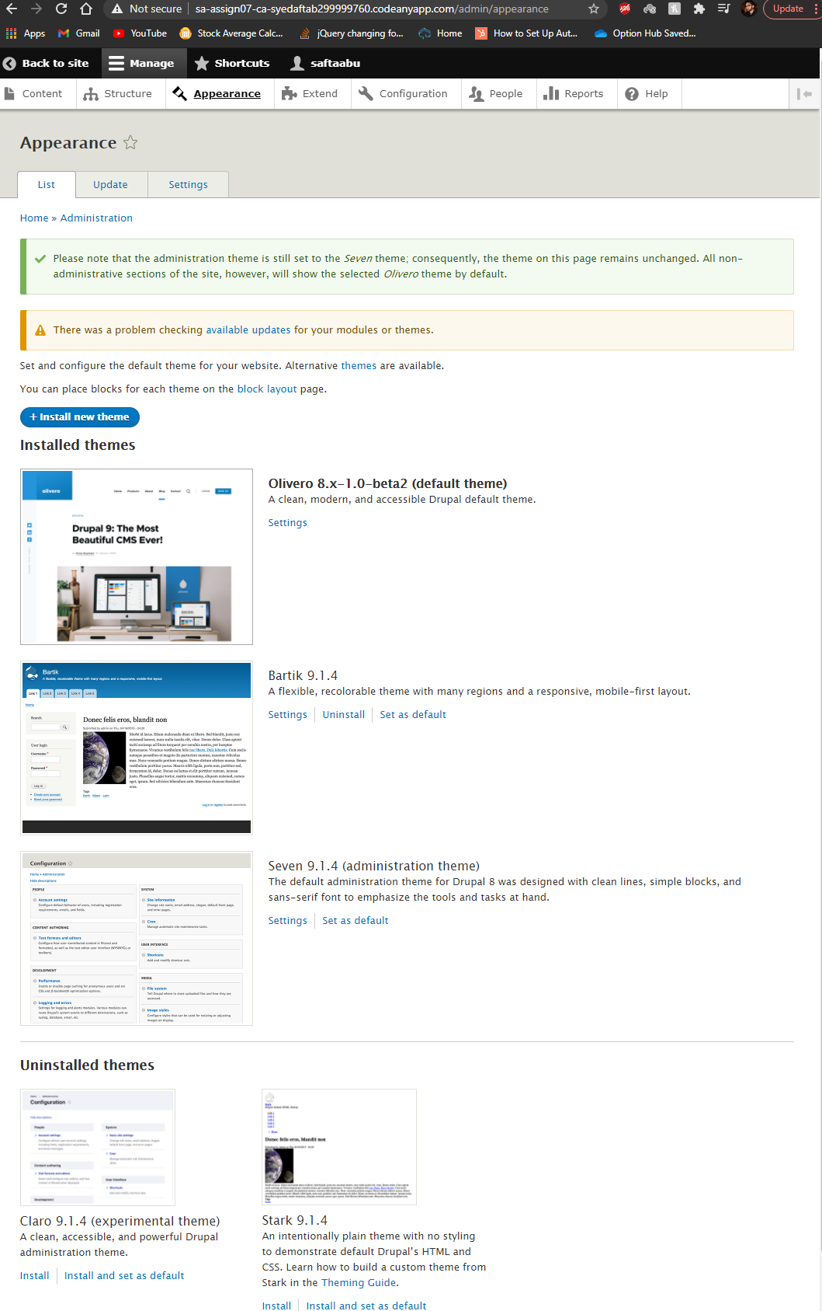]**

1. SCREEN CAPTURE of the front-end Drupal website with the site admin login page visible Do this by logging off the site, then login again. Please make sure the web browser address bar visible on the screen capture.  
   If you see an option for “Create new account” on the login page, you did not harden your Drupal site correctly.   
   **[I03]**  
   **[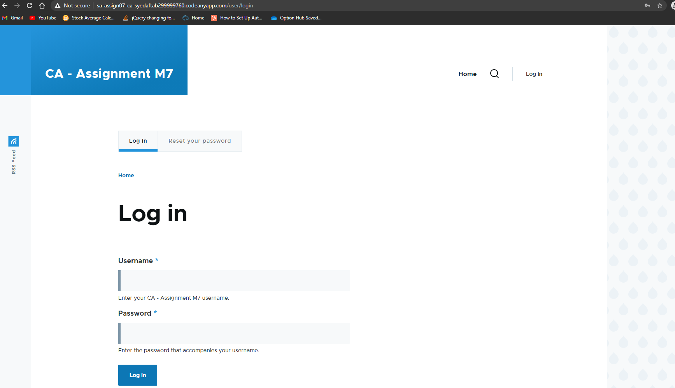]**
2. SCREEN CAPTURE of the backend Admin toolbar > People page  
   **[I04]**  
   **[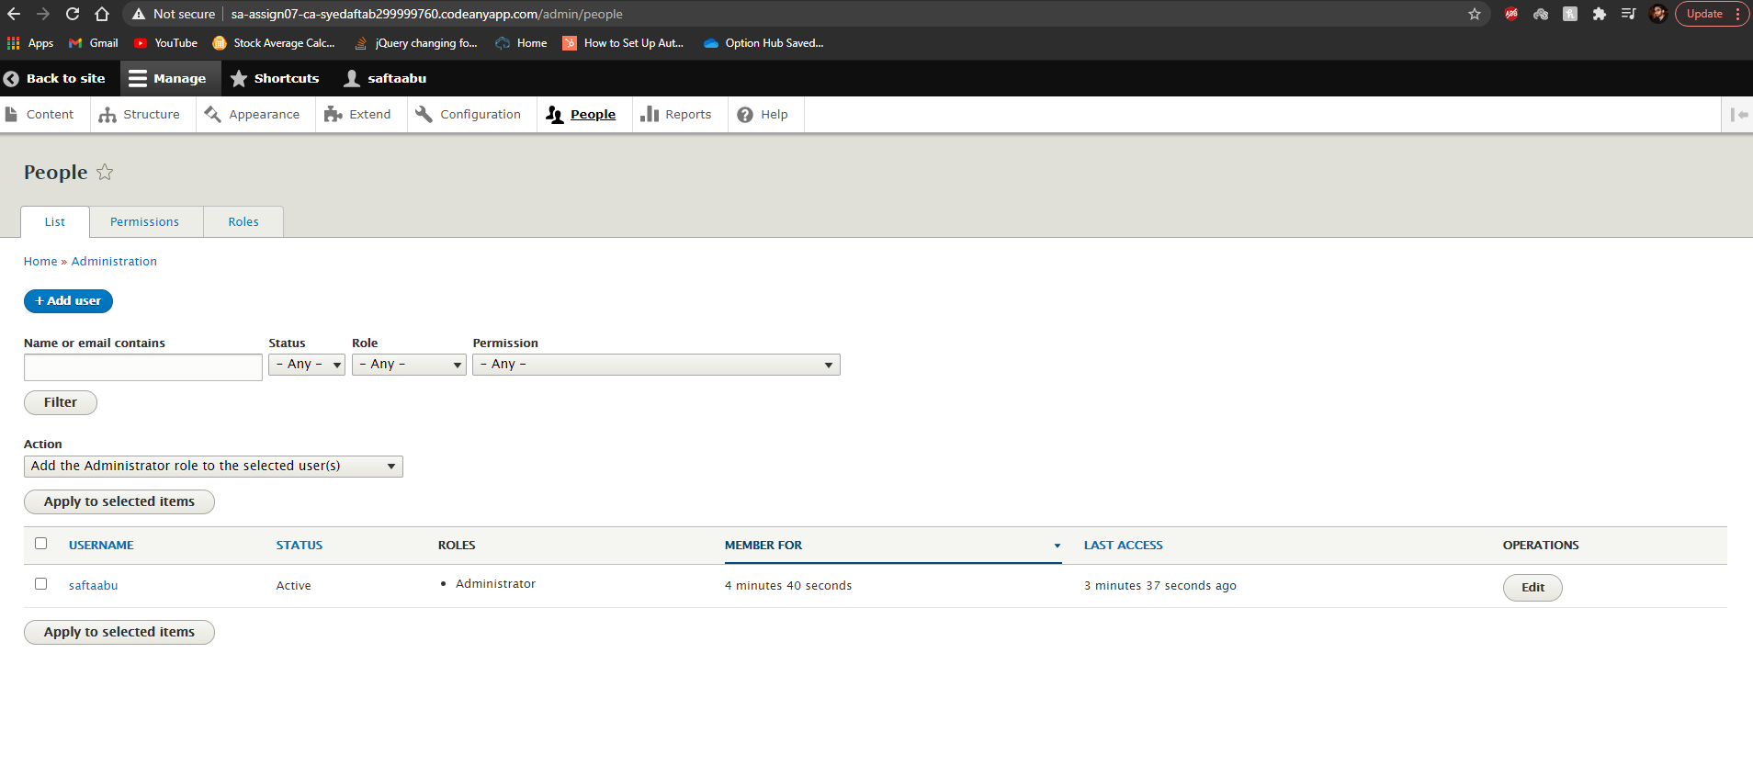]**

**Go back to the instructions and begin work on Part J.**

**Part J -** Extend the Codeanywhere Drupal 9 Site **– Add Content**

1. SCREEN CAPTURE of the backend Admin toolbar > Content – filter Content type by   
   Basic page.   
   **[J01]**

**[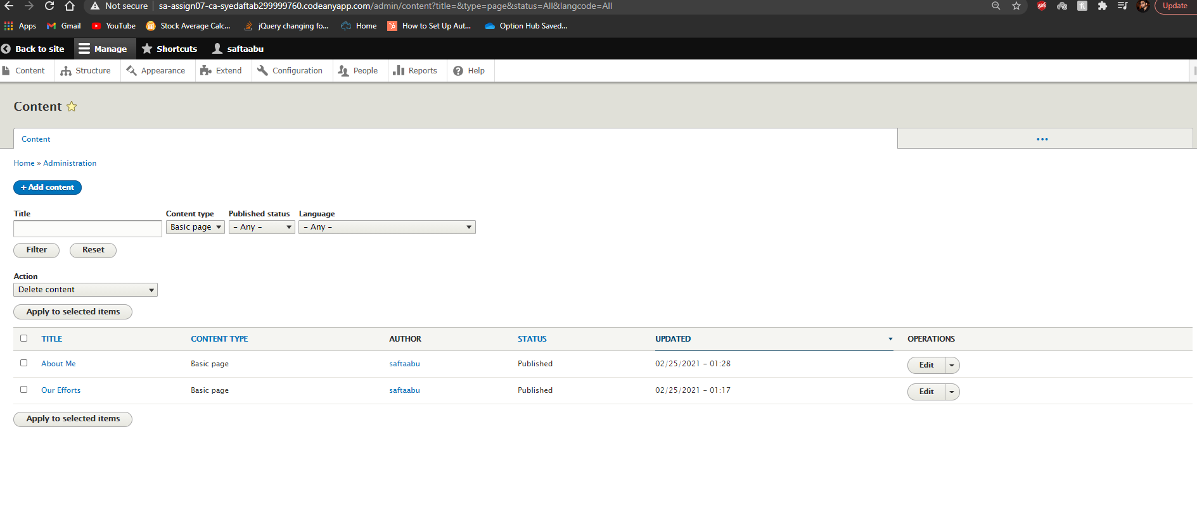]**

1. SCREEN CAPTURE of the backend Admin toolbar > Content – filter Content type by Article.   
   **[J02]**

**[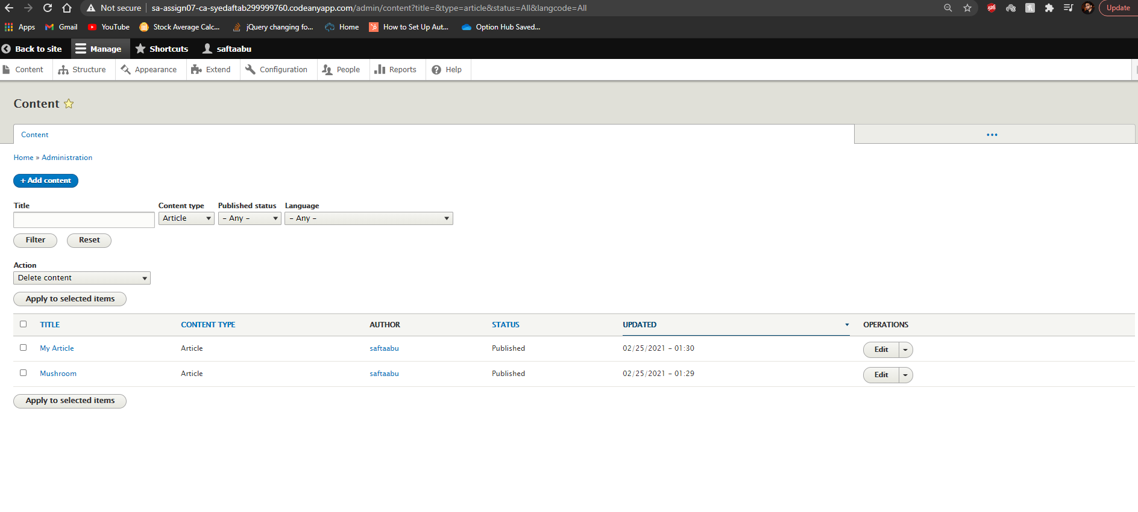]**

1. SCREEN CAPTURE of the backend Admin toolbar > Configuration > URL alias   
   **[J03]  
   [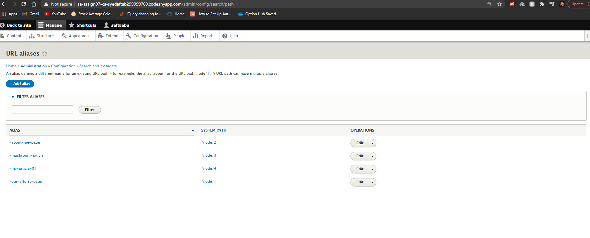]**
2. SCREEN CAPTURE of the front-end Codeanywhere website home page, with the web browser address bar visible and a main menu Basic page selected.   
   **[J04]  
   [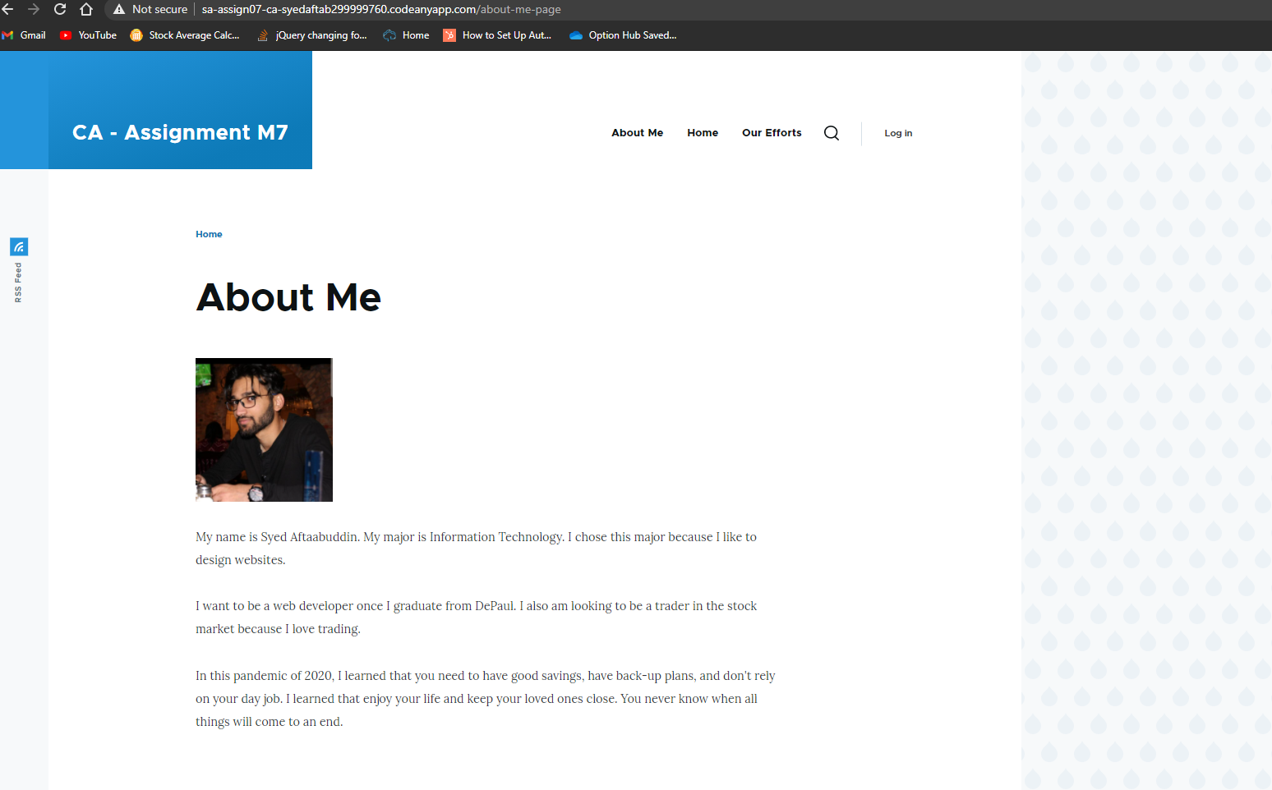]**
3. SCREEN CAPTURE of the front-end Codeanywhere website home page, with the web browser address bar visible and a Homepage Article selected.   
   **[J05]  
   [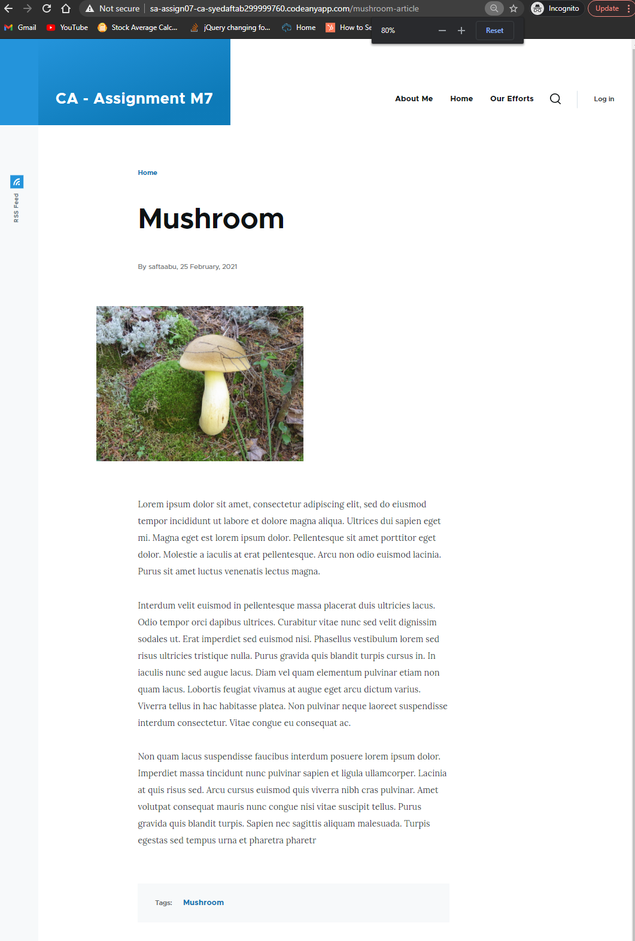]**
4. Go back to the instructions and begin work on Part K**.**

**Part K – Assignment Wrap up: (REQUIRED)**Answers to questions 1-3 are required to receive points for this section.

1. **Did you have any problem or issues completing this assignment?   
   [K01]  
   This is not an optional question.   
   [**NO**]**
2. **If you answered yes above, did you contact the instructor or tutor for help?  
    [K02]  
    [**Yes or No Answer here**]**
3. If you answered YES for **[K01]** and YES for **[K02]** above, did the instructor or tutor assist you and resolve your issues in a timely manner?  **[K03]   
   *Required if you answered YES** for **[K01]** and **YES** for **[K02] – Otherwise optional.  
   [**Did the instructor or tutor assist you and resolve your issues in a timely manner?]
4. If you answered **YES** for **[K01]** and **NO** for **[K02]** above, is there a reason you did not contact the instructor or tutor for assistance?   
   **[K04]   
   *Required if you answered YES** for **[K01]** and No for **[K02] – Otherwise optional.  
   [**Reason why you did not seek assistance**]**